Programming for the DALSA CL-P1 4096 Line Scan Camera and the DALSTAR 1M30 Area Scan Camera

Jason Bourgeois
Summer 2002
Helpful Hints:

For any specific V.I. that you are trying to figure out, there may be useful information in different places. Here is how to find some of it:

- Look on the panel of the V.I.
- If LabVIEW Context Help is on, place the cursor on the V.I. icon in the top right hand corner.
- If LabVIEW Context Help is on, place the cursor on the different controls.
- Look on the wiring diagram.

The DALSA CL-P1 4096 Line Scan Camera

The code for these programs is in the directory:
C:\Program Files\National Instruments\LabVIEW 6.1\J Bourgeois 2002\DALSA CL-P1 4096

The Bare Minimum:

This is a very quick tutorial on the most fundamental codes for the CL-P1 4096 line scan camera.

Taking Pictures:

Piranha Grab Sequence.vi

The most important LabVIEW V.I. for taking pictures is the Piranha Grab Sequence V.I. (located in the camera If you are taking data, you need at least one calibration image when the jet flow is blocked and one image when the jet is flowing. For this situation, the Number of Images to Grab control should be set to 1. For a set of multiple data image frames, this number can be set to whatever the user chooses. When multiple images are taken, one may vary the numbers in Skip Table depending on how many frames one wants to skip before acquiring the next image.
The Line Rate control will control how long the interval is between frames being grabbed from the camera. The maximum is 11.000 kHz for this camera. Each image is a collection of these lines, so for an image with a height of 400 lines and 11.000 kHz line rate, the camera will have taken 400 frames with a time of

1 / (11kHz) = 90.91 µs

between each line, making for a total sample time of 36.36 ms. The number of lines in an image may only be manipulated from MAX (National Instruments Measurement and Automation Explorer) under the camera properties, but can be used for extended or shortened samples.
The PRIN signal control will control the integration time for the camera when the camera is in the “Controlled Integration” mode (the other mode is “Total Integration” where the camera exposure is constant). Adjust the PRIN control to limit the exposure time of the camera. It is important that the images are not saturated. This can be seen on the intensity profile that is plotted real time when the camera is on. It is recommended that the exposure time be as long as possible, but insuring that any images taken will not be saturated.
Images, if used for processing should always be saved as bitmaps, so do not change the Saved Image Type control unless you need the image in another format for a specific reason.

Saving Images: The V.I. will save images in the specified path indicated by the folder name (which must exist before the V.I. is run, or the images cannot be saved). The calibration image will be saved with a name beginning with the name prefix followed by Calib (eg. If the image is to be of type bitmap and the name prefix is “seq”, the calibration image will be saved as seqCalib.bmp). The data images are named the same way, but instead of the postfix Calib, they have a number based on the order the image was taken (so the first data image would be saved as seq0.bmp, the second as seq1.bmp, etc.) 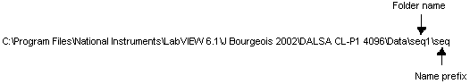
The Position, Forcing Frequency, and Jet Velocity string controls do nothing to the camera taking process, but are saved in a sequence info file along with the line rate called Name Prefixinfo.txt (eg. seqinfo.txt) to help with data management.

Camera Picture

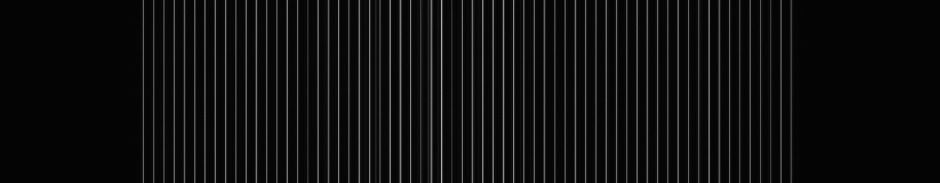

Data Analysis:

Wavefront Construction.vi

The core of wavefront construction is the determination of the focal spot centroids on an image. Wavefront Construction V.I. has two ways of centroiding, either using a Centre of Mass calculation, or a Cross-Correlation with a Gaussian curve, which can be chosen according to the Centroiding Method control.
You may also notice two frames containing controls, one called ‘Centre of Mass’, the other titled ‘Gaussian’. N.B.: These controls are set to good default values and do not need to be changed if the setup is not changed (e.g. a different lenslet array is used); only change them if you have a good reason. Depending on the centroiding method used, you may vary the controls in the specified frame to adjust the centroiding routine. The Window Half-Width control under ‘Centre of Mass’ controls the width of the box over which the centre of mass algorithm is applied (the box being centered over the brightest pixel of a focal spot). Under ‘Gaussian’ there are two analogous controls titled Box Length and Sub Length. The former being the original search box length, the latter being the length of a subset of the original box, centered on its brightest pixel. These should always be an odd number so the box may be centered on a single pixel. The Accuracy control controls the accuracy of the centroids (although greater accuracy is found than that given by the control by the next power of 2 smaller, as was done by Bob Pierson in the original C code for the Gaussian centroiding). The default gives very good results. DO NOT SET ACCURACY TO ZERO! (in Bob Pierson’s code, setting accuracy to zero would give the default value of 0.01 as this control does). The Sigma control controls the width of the Gaussian used to cross-correlate the focal-spots. Setting the control to zero will force the centroiding routine to find the optimum value for Sigma itself.
Once the centroids are determined for a certain calibration image (with the jet flow blocked) and a data image (with the jet flow on), a determination of the wavefront slopes can be found according to the relationship:

Θ_{x,l} = p_{x,l} – p_{x,l}|_{CAL}
L

Where Θ_{x,l} is the x-slope for lenslet l, p_{x,l} is the x-centroid from the data image for lenslet l, p_{x,l}|_{CAL} is the x-centroid from the calibration image for lenslet l, and L is the focal length. These slope measurements are presented in the indicator named Theta.
These slopes can then be used to integrate the actual wavefront. The method used is analogous to a 1D geometrical configuration like that of Hudgin (see different papers or books on wavefront reconstruction) where N discreet wavefront slopes are measured and integrated for N + 1 wavefront phase values where the slope measurements points fall in the middle of the phase measurement points (i.e. a slope measurement is taken to be the finite difference approximation of the phase derivative for two phase points lying on either side of the slope measurement point). The geometry is shown below where a dot represents a phase measurement point and a horizontal line indicates a slope measurement point.

Wavefront Reconstruction Geometry Used

With the 64 lenslet array used, we obtain 64 wavefront slopes and 65 phase values. These are presented in the Phase Values indicator. The integrated wavefront is a series of linear splines connecting these phase points. The wavefront is also tied down at the first phase point (Φ₀ = 0) because the system is only based on slope measurements, and so one extra condition must be satisfied for a single solution.
Because tilt in the wavefront is frequently seen, linear regression is done on the wavefront to find the line of best fit which is then subtracted from the wavefront so that the most information can be taken from viewing the wavefront (especially in a time series).
As was mentioned earlier, an image consists of a number of lines specified in MAX for the specific camera interface. This means that there are as many OPDs (optical path differences, i.e. wavefronts) that we may integrate. The control titled Image Centroiding Line is the line of the images that will be centroided and integrated for the OPD.

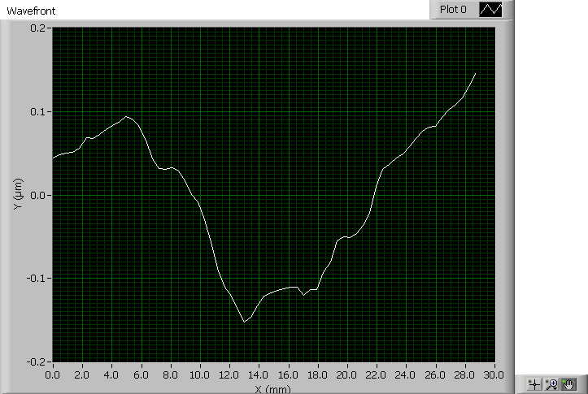
Integrated OPD Slice From CL-P1 4096

The switch with the options of ‘Data’ of ‘Calibration’ allows the user (before running the V.I.) to choose which image to use when taking the intensity profile.
When the V.I. is running, after the integration has taken place, it continues running until the stop button is pressed, allowing the user to choose different options from the Analysis Options menu.
- The first option, ‘Display Centroids’, displays the data and calibration images with the found centroids overlayed as little boxes.
- The second option, ‘Display Vector Plot’, displays the data image with overlayed scaled vectors indicating the direction (seen by the arrow head) and magnitude (seen by both the length and the 256 colour spectrum going from white to red).
- The third option, ‘Wavefront Sequence’, opens Wavefront Sequence.vi. Most controls in this V.I. are quite similar to those in Wavefront Construction.vi, because it does the same thing, it integrates wavefronts. The big thing to know here is that it has two operating modes: ‘Sequence’ and ‘Timed’. The ‘Sequence’ mode will likely not be useful without conditionally sampled data, because it takes a set of data images with their corresponding calibration image that are contained in an image sequence folder (see Piranha Grab Sequence.vi), integrates each of them at the indicated Centroiding Line, and shows the wavefronts on the display in a sequence with the variable speed control Delay. The ‘Timed’ mode takes in an OPD text file (see OPD Plot.vi below) and presents the time series of wavefronts contained within the same way that was done for the ‘Sequence’ mode.
- The fourth option, ‘3D Intensity Spectrum’, shows a 3D view of the data image intensity profile.
- The fifth option, ‘OPD Plot’, is probably the most interesting and useful. It opens up OPD Plot.vi which is explained below

OPD Plot.vi

OPD vs. Time
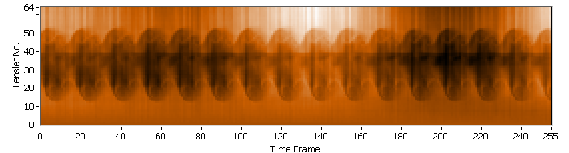

The OPD Plot V.I. has two modes: ‘Open’ and ‘Create’, controlled by the switch on the left of the V.I. The two modes have their own frames which specify their corresponding controls. The ‘Open’ mode is simple; it opens the previously created OPD data file that is stated in the control OPD Data File. The control contains the name of the text file in the directory

C:\Program Files\National Instruments\LabVIEW 6.1\J Bourgeois 2002\DALSA CL-P1 4096\Data\OPD Data

You do not need to include the extension .txt, it will be added anyways. The data from the OPD data file is read into the program and presented on the intensity plot. Also presented is the sequence information that is contained in another text file. For every OPD data file, there is an information file whose name is the same as the OPD data file, but with the word info added to the end: for example, for an OPD data file named data1.txt, there is an information file that gives imformation about the sequence called data1info.txt. For this example, the input to the OPD Data File control should be ‘data1’.
The intensity plot has the phase point number on the vertical (there are actually 65 phase points, from 0 to 64, but this axis corresponds to the position of the wavefront on the lenslet array), and the time frame number on the horizontal. Knowing the number of time frames, as can be seen on the plot, and knowing the rate of acquisition (the ‘Line Rate’ as presented in the Sequence Info control), the time period may be found by

Total Time Period = Number of Frames/Line Rate

The ‘Create’ mode integrates many OPD wavefronts which can be presented as a timed sequence. Within the ‘Create’ mode, there are a few other options. The first is whether one wants to integrate a sequence of data images that are contained in an image sequence folder (explained under Piranha Grab Sequence.vi) or whether one only wants to integrate a single one. If the image sequence folder name input into the Image Folder Name control contains multiple data images, but the Sequence/Single Image control is set to ‘Single Image’, the first data image is the one that is integrated. If the V.I. is set to ‘Sequence’, the OPD data files are saved according to the Save OPD Data File As: input with a suffix added that is an underscore followed by the number it is in the series (eg. if the input for Save OPD Data File As: is ‘data1’ and the sequence folder defined by Image Folder Name contains 4 data images, the data files will be saved as ‘data1_0.txt’, ‘data1_1.txt’, ‘data1_2.txt’, and data1_3.txt).

Deviation Angle vs. Time
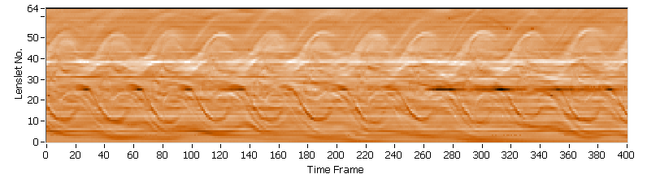

The second ‘sub-mode’ of ‘Create’ is defined by the OPD/Theta control. If ‘OPD’ is selected, the integrated wavefront is what is saved in the OPD data file. If ‘Theta’ is selected, the deviation angles (i.e. wavefront slopes) are saved in the OPD data file. The plots of deviation angle versus time are actually very useful in that more structure can be seen in the data compared to the OPD since some smearing occurs.
The Save OPD Data File As: control input is formatted in the exact same way as the OPD Data File control for the open mode.
The Centroiding Method control controls the way centroids are found.
The Lines to Centroid control indicate how many lines (starting from the very top of the input image) to centroid and integrate. This allows you to not always have to integrate the time sequence contained in the images (i.e., the images could contain more information than is extracted from them).
The Centroiding Iteration and Image No. indicators indicate the line and image being centroided, respectively, at any instant during the integration process.

Tip: If you wish to present the plots of either Deviation Angle vs. Time, or OPD vs. Time which are made by the OPD Plot V.I. (or any other plot, etc. in LabVIEW generally), the easiest way is to right click on the plot and select
Data Operations > Copy Data
After this is done, paste the data in any image program to manipulate and save in whatever format is wished. Also note that many attributes of the axes etc. can be changed in LabVIEW itself, if a specific format is desired.
The DALSTAR 1M30 Area Scan Camera

The code for these programs is in the directory:
C:\Program Files\National Instruments\LabVIEW 6.1\J Bourgeois 2002\DALSTAR 1M30

The Bare Minimum:

This is a very quick tutorial on the most fundamental codes for the 1M30 area scan camera

Taking Pictures:

1M30 Grab Sequence.vi

The picture-taking application for the 1M30 area scan camera is the 1M30 Grab Seqquence V.I. It is very similar to the Piranha Grab Sequence V.I. for the line scan camera. The Interface Name, File Path, Number of Images to Grab, Skip Table, Position, Forcing Frequency, Jet Velocity, Calibrate, and Start Grab Sequence controls work in the exact same way as they did in Piranha Grab Sequence.vi. Saved images and files follow the same convention that was used for the line scan camera as well. There is a difference, though, in the Saved Image Type control this time. Bitmap and Jpeg images, when saved, are 8-bit images, and PNG images are 16-bit. Since the 1M30 camera is neither 8- not 16-bit, but in fact 12-bit, the pixel values are scaled to the corresponding bit-depth for a given Saved Image Type by:

Pixel Val_{Saved} = (Max Val_{Saved Bit Depth} / Max Val_{Img Bit Depth})* Pixel Val_{Img}

Where Pixel Val_{Saved} is the value of a pixel in the saved image, Max Val_{Saved Bit Depth} is the maximum pixel value for the bit-depth of the saved image (for 8-bit, Max Val_{Saved Bit Depth} = 255; for 16-bit, Max Val_{Saved Bit Depth} = 32767 in LabVIEW), Max Val_{Img Bit Depth} is the maximum pixel value for the bit depth of the camera image (= 4095 because the camera is 12-bit), and Pixel Val_{Img} is the pixel value of the camera image.
The images that are saved are also rotated through 90° since the sensor of the camera rotates the image in the opposite direction by this amount (cf. DALSTAR 1M30P User’s Manual and Reference, pp. 16). Rotating it back has the effect of setting the image back to the ‘natural’ orientation which the picture was taken at. Not wanting to cause major delays due to pixel manipulation during the grab sequence itself, the rotation is not corrected until the image is being saved. This means that during the grab sequence, the picture one will view on the screen is actually a 90° rotation of what one would intuitively expect to see from the camera. What one would expect to be the top right hand corner is now the top left hand corner, the bottom left corner is not the top left, and so on. The Horizontal and Vertical Intensity Spectrum indicators refer not to what the image should look like, but to the image one sees on the screen (i.e. vertical means vertical on the screen but horizontal for what one would expect, and vice versa for horizontal). The intensity spectrums are centred on the brightest pixel of the image at any given time so as to allow the user to make sure no saturation occurs on the picture to be grabbed.
To control features of the camera, a V.I. will pop up each time the sequence is run. This V.I. will send the proper commands to the IMAQ board’s serial port to the camera for given acquisition and integration modes, values of gain, offset, programmed integration time, and frame rate. Once these values are input, hit the Send Command control to continue with the grab sequence.

Data Analysis:

Wavefront Construction (2D).vi

N.B.: It is highly recommended that the Spot Finding Method control is set to ‘Iterative with variable size’ and the Centroiding Method control is set to ‘Gaussian’.

There are two methods for wavefront reconstruction performed by this V.I. One is a direct matrix multiplication, and the other is an iterative technique that will solve the same system of equations as the non-iterative technique within a small degree of error. The first type of reconstruction is performed in Wavefront Reconstruction.vi and the second is performed in Iterative Wavefront Reconstruction.vi (see below). These can be toggled between with the Iteration Method control. For large arrays, like the 100X100 lenslet array currently used, the iterative technique may be the only method that will run without overloading the computer memory.
The N control gives the dimension of the lenslet array (the default is 100, which means a 100X100 lenslet array).
This V.I. has a very similar structure as the Wavefront Construction V.I. for the CL-P1 4096 camera. At the bottom of the panel, again there is a plot of the centroid locations and line profiles of the image. Because a single line is no longer being integrated at once, we have two dimensions, and the line profiles are taken over the horizontal and vertical directions of the highest intensity pixel. Again, the user may toggle between the data and calibration image over which to take the line profiles.
The user may again choose the centroiding method: ‘Gaussian’ or ‘Centre of Mass’, and along with these two options come two frames for which the parameters may be defined. The default parameters should be fine to use, only change them for a good reason. The ‘Centre of Mass’ Pixel Half Width control as well as the ‘Gaussian’ Accuracy and Sigma controls have the same function and are used the same way as was the case for the line scan camera. The Sub Size control is like the line scan Sub Length control, but it defines a square box size rather than a length. There is no original box size because the thresholding routine sets up what should be a good suggestion for what the box size should be.
The reconstructed wavefront is now not simply a two-dimensional curve, but a three-dimensional surface. The wavefront then is presented in two ways: as an intensity graph and as a 3-D plot, which can be moved and manipulated in LabVIEW to see different angles, etc.
Due to the time involved in integrating 10,000 phase values iteratively, as is the case with the 100X100 lenslet array, the user may save the wavefront data. When the V.I. is run, it will ask you first if you would like to integrate a new wavefront, or if you would like to open a previously integrated one. If you choose to integrate a new wavefront, after the V.I. is done processing, it will ask if the user wishes to save the wavefront data. The convention that was used when the V.I. was developed was to save the data in a location such as

C:\Program Files\National Instruments\LabVIEW 6.1\J Bourgeois 2002\DALSTAR 1M30\Data\wf1

where wf1 is an empty folder that already exists. In the specified folder will be saved the found centroid locations (both x and y) for both the calibration and data images, as well as the x- and y-slopes, integrated phase values, and the image paths that were defined by the user when the V.I. asked for the data and calibration images. (N.B. the fact that the V.I. saves the paths means that if all options in the V.I. want to be used, the calibration and data images must still exist in the same locations as they did when integrated.

Update (Aug 16, 2002): The Wavefront Construction (2D) V.I. now takes in as parameters the lenslet array specifications (Lenslet Pitch, Focal Length, and Reduction Factor) and has two methods for finding the box locations input into the centroiding routine (Spot Finding Method). Lenslet Pitch is the distance between lenslet in the lenslet array, Focal Length is the focal length of the lenslet array, and Reduction Factor is the percentage found from the ratio of the actual lenslet array size to the imaged lenslet array size. The Spot Finding Method control allows the user to choose between a thresholding method to find the spots (this assumes very low intensity noise and a uniform beam intensity) and an iterative technique. The iterative technique (since no noise filter was created for the thresholding technique as it was for the line scan camera) works much better. It finds the highest intensity pixel of the image and assumes it must be a focal spot (which it should be or the centroiding routine will give garbage anyways). Then, knowing the lenslet array parameters, it steps through the image to where other focal spots should be, makes sure a square array is sent out, and if the requested number of columns is less than the array, it will chop the array down to what should be the best subset for centroiding. (N.B. if the centroids seem to be drifting between noise and the actual spots, a way that could be used to stop this is to decrease the hard-wired number ‘portion of lenslet pitch to use as box’ in the eighth frame of the sequence structure of Find Spots.vi).

Wavefront Reconstruction.vi

The integration for the wavefront for the area scan camera is based on two slope values (x and y) at each lenslet subapperture point. Since the lenslet array is 100 X 100, there will be 20 000 slope values. These slope values are calculated by:

Θ_{x,l} = p_{x,l} – p_{x,l}|_{CAL}
L

Where Θ_{x,l} is the x-slope for lenslet l, p_{x,l} is the x-centroid from the data image for lenslet l, p_{x,l}|_{CAL} is the x-centroid from the calibration image for lenslet l, and L is the focal length. The y-slope is calculated the same way with the y-centroids.
The geometry for the phase reconstruction is that of Southwell, where x- and y-slopes are determined for the same points, and at which points the phase is also integrated. The geometry is shown below where dots represent phase slope measurement points, horizontal lines indicate x-slopes, and vertical lines represent y-slopes.

Wavefront Reconstruction Geometry Used (Southwell Geometry)
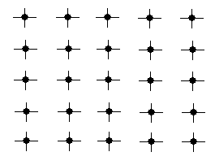

Knowing all of these slopes, Southwell’s technique is used to least-squares-fit the slope values to calculate the phase. Southwell’s technique is to take the average slope between two adjacent points and set it equal to the difference in phase divided by the step size between lenses (i.e. the finite difference approximation of the phase derivative between the two points.

S^{x}_{i,j+1} + S^{x}_{i,j} = Φ_{i,j+1} - Φ_{i,j} i = 1, N
2 h j = 1, N – 1

S^{y}_{i+1,j} + S^{y}_{i,j} = Φ_{i+1,j} - Φ_{i,j} i = 1, N - 1
2 h j = 1, N

This will give us N(N – 1) equations with the x-slopes and N(N – 1) equations with the y-slopes, for a total of 2N(N-1) equations. This system is overdetermined since we are only looking for N² phase values. This means we need a least squares solution. The system is set up with the form:

DS = AΦ

Where D is the matrix which averages the slopes which has a size
(2N(N-1)) X (2N²), S is the vector of slopes (x-slopes first) of length 2N², A is the matrix that calculates the finite differences of the phase values which has a size of (2N(N-1)) X (N²), and Φ is the vector of phase values with a size of N². Essentially, what is done when multiplying the slopes by the matrix D, is a conversion from the Southwell geometry to the Hudgin geometry, as is shown below.

Transformed Geometry (Hudgin Geometry)
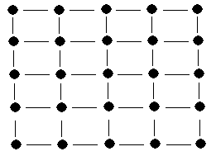

The least squares normal equations for this system are:

A^{T}DS = A^{T}AΦ

The problem with the system above is that it is completely defined by slopes, and therefore A is singular. Because of this, we must add one last condition to the system so that it is solvable. Herrmann’s condition of minimum norm (zero mean) is used. This means making an extended matrix A_{e} which has an extra row of all ones and an extended vector S_{e} which is the average slopes (DS) with an extra zero at the end (this sets the mean of the phases to zero). Our new system is then:

A_{e}^{T}S_{e} = A_{e}TAeΦ

Which has a solution:

Φ = (A_{e}^{T}A_{e})⁻¹A_{e}^{T}S_{e}

Iterative Wavefront Reconstruction.vi

For large values of N (eg. the N= 100 lenslet array originally used with the DALSTAR 1M30 camera), the direct matrix multiplication technique presented above is impractical due to the size of the arrays. Analyzing the system of equations

A^{T}DS = A^{T}AΦ

shows that our system is actually just N*N equations (since there are N*N phase measurements being integrated) corresponding to the situation presented below.

Iterative Wavefront Reconstruction Equation Formulation

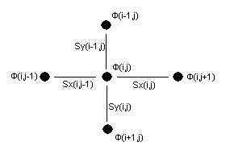

The diagram shows a mid lenslet (i.e. a lenslet that is neither on an edge or in a corner) corresponding to a phase value Φ_{i,j} . The slope values shown are actually the average slopes (DS). In our original system, the diagram above would be represented by the four equations

S^{x}_{i,j} = Φ_{i,j+1} - Φ_{i,j}
h

S^{x}_{i,j-1} = Φ_{i,j} - Φ_{i,j-1}
h

S^{y}_{i,j} = Φ_{i+1,j} - Φ_{i,j}
h

S^{y}_{i-1,j} = Φ_{i,j} - Φ_{i-1,j}
h

For each equation of

A^{T}DS = A^{T}AΦ

These four equations (or less for an edge or corner) are transformed into the single equation

S^{y}_{i-1,j} - S^{y}_{i,j} + S^{x}_{i,j-1} - S^{x}_{i,j} = Φ_{i,j} - Φ_{i-1,j} + Φ_{i,j} - Φ_{i+1,j} + Φ_{i,j} - Φ_{i,j-1} + Φ_{i,j} - Φ_{i,j+1}
h h h h

or

(S^{y}_{i-1,j} - S^{y}_{i,j} + S^{x}_{i,j-1} - S^{x}_{i,j}) h = 4Φ_{i,j} – (Φ_{i-1,j} + Φ_{i+1,j} + Φ_{i,j-1} + Φ_{i,j+1})

For corner lenslets (i.e. i = 1 or N, and j = 1 or N), there would only be two slope measurements, a coefficient of two in front of Φ_{i,j} and only two nearest neighbor phase values in the equation (since instead of four equations, we would only be combining two equations). For edges (i.e. i = 1 or N, and j = 2 to N-1; or j = 1 or N, and i = 2 to N-1), for each of these, there would only be three (since we would only be combining three equations.
If we call the coefficient in front of Φ_{i,j} g_{i,j}, where g_{i,j} = 2 for corner lenslets, 3 for edge lenslets, and 4 for mid-array lenslets, and if we define the nearest-neighbor phase average Φ_{i,j}

Φ_{i,j} = (Φ_{i-1,j} + Φ_{i+1,j} + Φ_{i,j-1} + Φ_{i,j+1}) / g_{i,j}

and

b_{i,j} = (S^{y}_{i-1,j} - S^{y}_{i,j} + S^{x}_{i,j-1} - S^{x}_{i,j})h

our system becomes

Φ_{i,j} = Φ_{i,j} + b_{i,j} / g_{i,j}

which is the basis for the iterative solution

Φ_{i,j}^{(m+1)} = Φ_{i,j} ^{(m)} + b_{i,j} / g_{i,j}

Since Φ_{i,j} does not appear anywhere on the right hand side, we will add and subtract it and induce the relaxation parameter w.

Φ_{i,j}^{(m+1)} = Φ_{i,j}^{(m)} + w( Φ_{i,j} ^{(m)} + b_{i,j} / g_{i,j}- Φ_{i,j}^{(m)})

For the wavefront construction matrices, the optimal value of w is known to be

w = 2 / [1 + sin(π / (N+1) )]

This method should converge on the solution within an additive constant (due to the fact that the solution is based on wavefront slopes, and a method for tying down the solution is needed. For consistency, this additive constant is subtracted out to get zero mean (Herrmann’s condition) as was done for the exact solution with the matrix multiplication. This method will not overload the memory of the computer for big values of N, like with the N = 100 lenslet array which is used at the time of writing this, but it is slower since it is not a direct matrix multiplication.

